Chapter 6 Review Quiz

Instructions:
Do not submit this document. You will be answering these questions on our course Mastering Geology page. Use this document to mark your answers for quick reference.

1) The two basic categories of weathering are ________.
A) mechanical and chemical
B) mechanical and physical
C) chemical and physical

2) Which one of the following is an important mechanical weathering process for enlarging fractures and extending them deeper into large boulders and bedrock?
A) oxidation
B) eluviation
C) hydrologic cycling
D) frost wedging

3) Which of the following best describes sets of fractures in relatively fresh bedrock, such as granite, which are roughly parallel to the land surface?
A) thermal expansion cracks
B) sheeting fractures
C) hydrolytic failures
D) columnar joints

4) Which one of the following statements concerning mechanical weathering is NOT true?
A) It reduces grain sizes of rock particles.
B) It allows for faster rates of chemical weathering.
C) It is important in the formation of talus slopes.
D) It involves a major change in the mineral composition of the weathered material.

5) Assume that water filling a crack in a rock undergoes cycles of freezing and melting. Which of the following statement is TRUE?
A) Water expands as it melts, causing the crack walls to be pushed apart.
B) Water shrinks as it freezes, causing the crack walls to be drawn closer together.
C) Water expands as it freezes, causing the crack walls to be pushed apart.
D) Water shrinks as it melts, causing the crack walls to be pulled closer together.

6) Which term best describes an accumulation of angular rock fragments at the base of a steep, bedrock slope or cliff?
A) trellis slope
B) taliche slope
C) tellus slope
D) talus slope

7) Half Dome in Yosemite National Park is a good example of ________.
A) joints
B) an exfoliation dome
C) frost wedging
D) chemical weathering

8) Which of the following is/are most susceptible to chemical weathering by dissolution?
A) quartz
B) clay minerals
C) iron oxides
D) calcite

9) What mineral particles are the dominant coloring agents in reddish, brownish, and yellowish soils?
A) soluble potassium and sodium bicarbonates
B) humus and calcium carbonate
C) very fine-sized, silica and calcite particles
D) dust-sized grains of iron oxides

10) ________ is formed when carbon dioxide is dissolved in water.
A) Hydrochloric acid
B) Carbonic acid
C) Calcite
D) Potassium

11) Which of the following do feldspars weather to form?
A) feldspar grains
B) clay minerals
C) limonite
D) hematite

12) Oxidation plays an important role in the weathering of ________.
A) granite
B) plagioclase
C) ferromagnesian minerals
D) silicate minerals

13) Which of the following components of granite are more resistant to chemical weathering?
A) potassium feldspar
B) quartz
C) Potassium feldspar and quartz are equally resistant to chemical weathering.

14) What two factors speed up rates of chemical reaction and weathering in rocks and soils?
A) low temperatures; very dry
B) low temperatures; very moist
C) high temperatures; very dry
D) warm temperatures; very moist

15) What process does the diagram below illustrate?

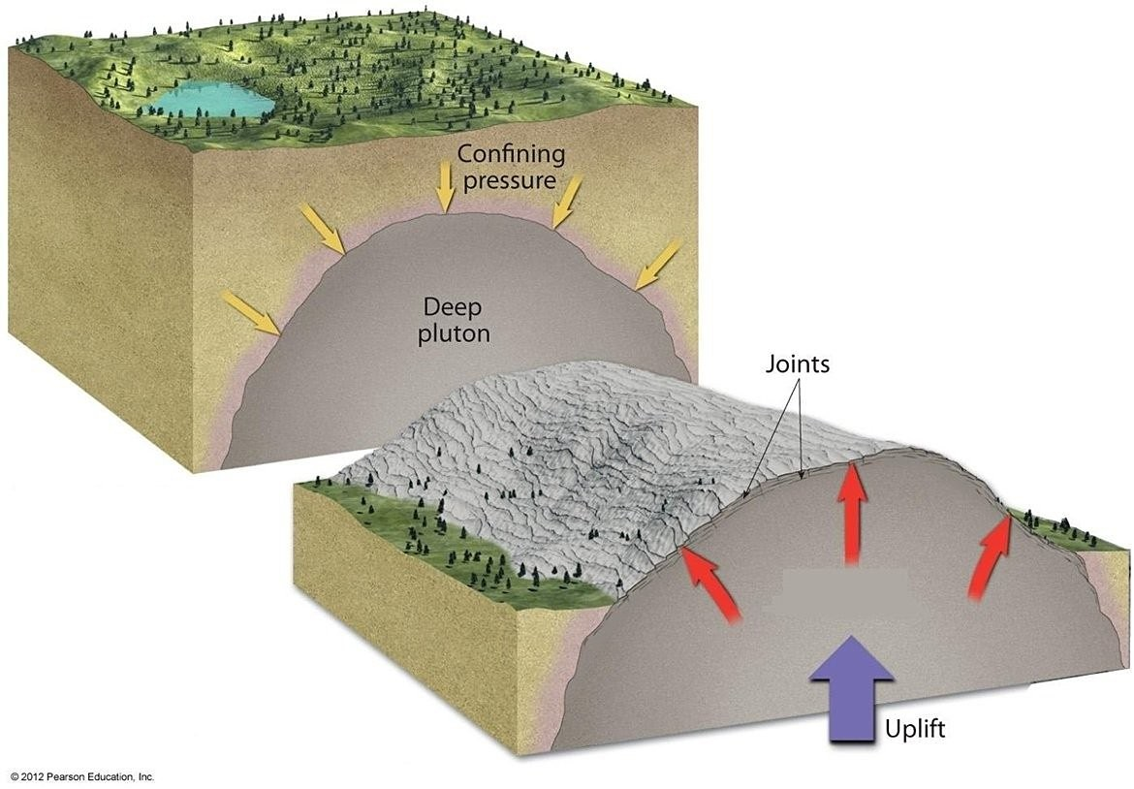
A) sheeting
B) exfoliation
C) frost wedging
D) root wedging

